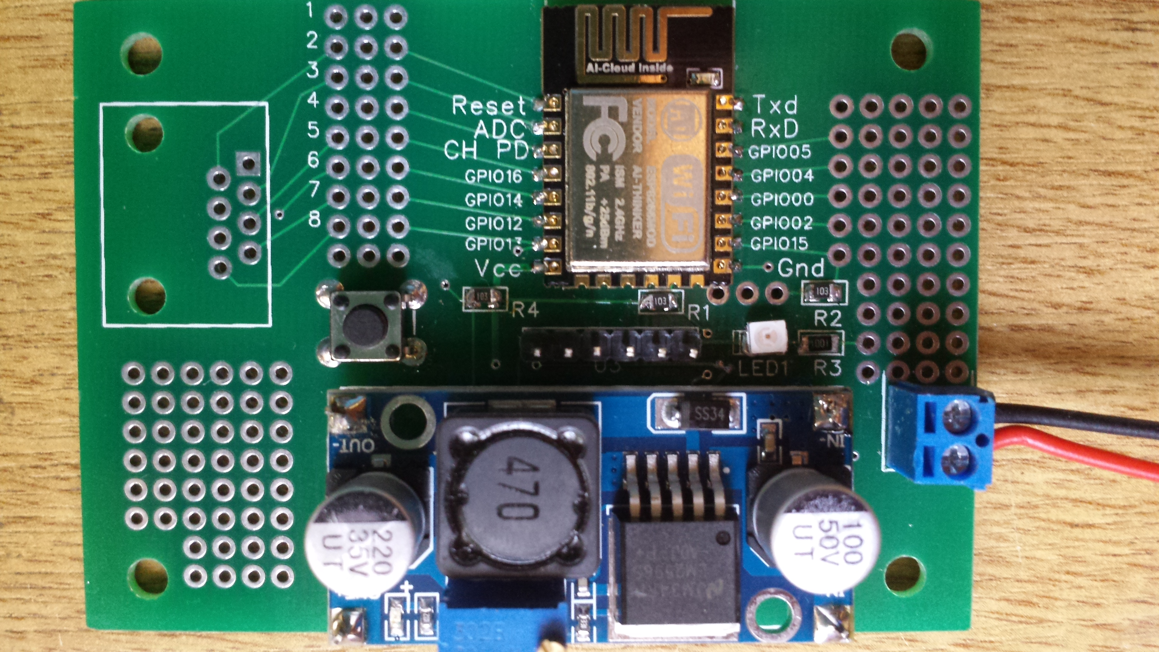
3.3VBuck converter supply
12V In
Connection area
Connection area
ESP-12
LED
Extra prototyping area
GPIO00 switch
Program upload header

Introduction
If you are building several one off ESP8266 based devices it is useful to have a PCB with all the basic circuitry already on. This board does this for the ESP-12 or ESP-03 units. The main features are:
- Mounting for ESP-12 (on top) or ESP03 boards (on bottom underneath supply)
- Mounting for LM2596S DC-DC buck converter
- Header to connect:
  - Reset switch
  - Upload switch (GPIO00)
  - RxD & TxD (e.g. USB to logic level [3.3V !])
- LED
- Push button switch (GPIO00)
- Supply input connector (0.15” & 0,2”)
- 0.1” spacing holes in prototyping areas for connections, components and connectors
- Mounting holes
- RJ45 connector mounting
- Required pull-up & pull down resistors

Circuit
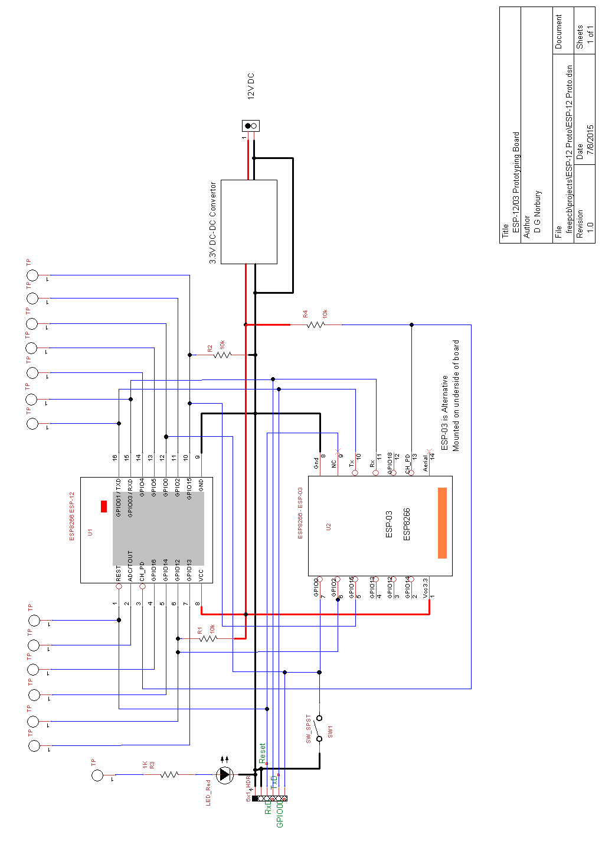

Construction
Points to note during construction:
- Only mount ESP-12 OR ESP-03 (not both)
- If using adjustable buck converter adjust the output voltage BEFORE connecting up to the ESP device!
- The mounting of the buck converter is designed to be via pins so that it stands off the main board
- The supply input connector can be 0.15” or 0.2” (in which case it uses part of the prototyping area)
- There is a mistake with the RJ45 connector requiring. it to be mounted on the underside of the board
- The LED and associate resistor are not connected. They need to be patched to the GPIO of your choice.
- USB-Serial converters: the CP2102 ones are more reliable than the FTDI based ones.

Connections
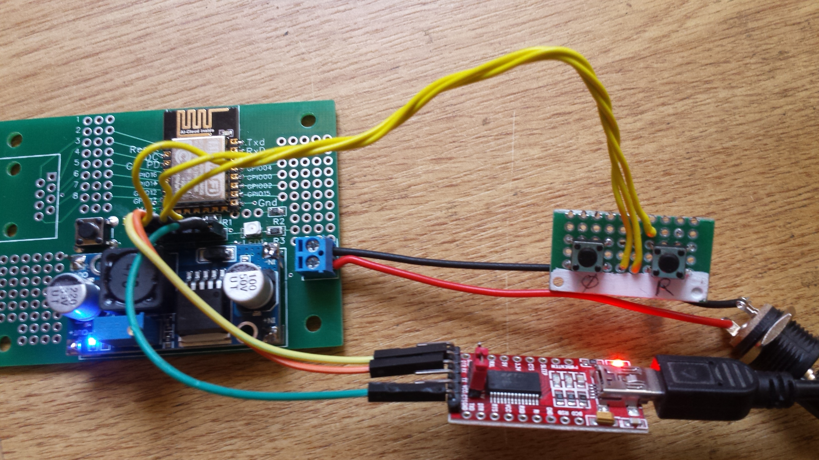
12V
USB interface to virtual COM port
Rest & Upload switches
Upload header

Software
For software development I use the Eclipse set-up on Windows. This link shows how to install that package:
http://www.esp8266.com/viewtopic.php?f=9&t=820&sid=783b2f3021078ab65722108fdfadd5d8
or Google My Espressif DevKit for Windows + Eclipse IDE

Useful Sites
- Scrgill's Technical Blog http://tech.scargill.net/
- ESP8266 Community Forum http://www.esp8266.com

Example Project
A starting point and example project “ESP Prototype Demo” has been created. It assumes:
- LED on GPIO05
- Switch on GPIO00
- Potentiometer on ADC
It uses:
- easygpio for IO
- stdout sets up serial output, leaving RxD free for IO use
- MQTT library
- WiFi_Connect function to simplify setting up WiFi
- Config.c loads/saves configuration data in flash memory

The create a new project based on “ESP Prototype Demo”:
- File/New/C Project
- Empty executable project using MinGW GCC
- Next, Advanced Settings
  - Tool Settings, GCC C Compiler, Includes, add Include Path “C:\Espressif\ESP8266_SDK\include”
  - MinGW Linker, Libraries, add Library Search Path “C:\Espressif\ESP8266_SDK\\libraries”
  - ToolChain Editor, current builder, change to org.eclipse………
- Finish
- Right click new project name/Properties
  - Select C/C++ Build
  - Remove check 'Use default build command'
  - Set build command to
    - mingw32-make.exe -f "${ProjDirPath}/Makefile"
  - Remove check 'Generate Makefiles automatically'
  - Remove '/Debug' from Build directory field
- Copy include, driver, modules, mqtt and user folders and Makefile from “ESP Prototype Demo” project
- In 'Make Target' window/tab
  - right click on your new project / new..
  - Set Target name to 'all', remove check 'use builder settings' and fill in 'mingw32-make.exe -f "${ProjDirPath}/Makefile"'
  - repeat with 'clean' and 'flash'
- Edit makefile and change ESPPORT to COM port connected to board

